BANKING APPLICATION
MULTI-CLOUD CI/CD & CONTAINER DEPLOYMENT
A step-by-step guide for complete beginners
Jenkins | GitHub | Maven | Docker | Docker Hub | Ansible | AWS EC2 | Azure VM
Prepared from the course solution guide, the project repository, and the learner's supplied execution screenshots.
Version 1.0 | 01 November 2026

How to use this guide
This guide explains the course-end project called “Application Deployment to Multi-Cloud”. It is written for someone who is new to Linux, Git, Jenkins, Docker, Ansible, AWS and Azure. Read the chapters in order and perform one step at a time.
- The course solution document is the primary source for the required project sequence.
- Your GitHub repository and screenshots are used to describe what has actually been configured and observed.
- Where a course instruction is unsafe, ambiguous, or inconsistent, the guide calls it out and gives a safer implementation. Do not blindly copy a command that exposes credentials.
- Screenshots supplied in Capstone project 2.docx are retained unchanged in the Screenshots appendix and in the companion screenshots folder.
Important status rule — A green Jenkins build means the stages in that Jenkinsfile completed. It does not automatically prove that Ansible deployed the application to both AWS and Azure. The Ansible multi-cloud deployment must be separately configured and verified.

1. Project at a glance
The goal is to take a Java Spring Boot banking application stored in GitHub, build it automatically with Jenkins and Maven, package it into a Docker image, publish that image to Docker Hub, and use Ansible from the Simplilearn lab (the Ansible controller) to install Docker and run the image on two remote virtual machines: one in AWS and one in Azure.
Component | What it does in this project | Simple real-life analogy
GitHub | Stores source code, Dockerfile, Jenkinsfile, inventory and Ansible playbook. | A shared, versioned project cupboard.
Jenkins | Runs the pipeline stages when a build is started or triggered. | A factory supervisor assigning each production step.
Maven | Compiles Java code, runs configured tests and packages a JAR. | A workshop that turns source materials into a finished package.
Docker | Builds and runs the application as a container image. | A sealed, repeatable delivery box containing the app and runtime.
Docker Hub | Stores the versioned image so deployment machines can download it. | A central warehouse for delivery boxes.
Ansible | Connects to AWS and Azure over SSH and executes deployment tasks. | A remote operations engineer following a repeatable checklist.
AWS EC2 VM | One target server for the banking application. | One branch/server location.
Azure VM | The second target server for the same application. | A second branch/server location.
Swagger UI | Lets a user inspect and call the REST API endpoints. | A control panel for trying the application's API operations.

2. What is the expected architecture?

2.1 End-to-end flow
Developer / learner
|
| pushes source code and pipeline files
v
GitHub repository
|
| Jenkins reads Jenkinsfile and checks out code
v
Jenkins CI pipeline (Simplilearn DevOps lab)
|
+--> Maven: compile / test (if configured) / package
|
+--> Docker build: create bankingapp:<tag>
|
+--> Docker Hub: push image to siri3/bankingapp:<tag>
|
v
Ansible controller (Simplilearn lab)
|
+---- SSH using EC2 PEM key ----------> AWS EC2 Ubuntu VM
| |
| +--> install Docker
| +--> pull image
| +--> run container :8989
|
+---- SSH using Azure VM credentials --> Azure Ubuntu VM
|
+--> install Docker
+--> pull image
+--> run container :8989
Users / browser
|
+--> http://<AWS-PUBLIC-IP>:8989/bank-api/swagger-ui.html
|
+--> http://<AZURE-PUBLIC-IP>:8989/bank-api/swagger-ui.html
The Ansible controller is the machine that runs Ansible commands. In this course, it is the Simplilearn lab machine where Jenkins is also installed. The AWS and Azure virtual machines are managed target hosts.

2.2 The two pipelines/stages of responsibility
Area | Responsibility | Proof required
CI / image creation | Jenkins checks out code, runs Maven, builds the Docker image and pushes it to Docker Hub. | Jenkins stage view and console output; image/tag visible in Docker Hub.
CD / remote deployment | Ansible connects to both cloud VMs, installs Docker, removes/replaces the old container, starts the new container and checks it. | Ansible playbook output for both hosts; docker ps on each VM; Swagger URL works on each VM.

Do not confuse these — A Jenkins job can be green while only building and running a container on the Jenkins lab machine. The project is multi-cloud only when the AWS and Azure target hosts both receive and run the image through the intended deployment process.

3. Understand the key words before starting
Term | Beginner-friendly meaning
CI – Continuous Integration | Automatically fetch and build code frequently so integration problems are detected early.
CD – Continuous Delivery/Deployment | The automated steps that prepare or release the built application to an environment.
Pipeline | A sequence of named stages executed in order.
Repository | A Git-managed folder containing code and project files.
Branch | A line of development in Git. This project uses the master branch in the configured Jenkins job.
Jenkinsfile | A text file that describes pipeline stages as code.
JAR | A Java archive file produced by Maven; it contains the packaged Java application.
Image | A read-only template containing the application and the dependencies needed to run it.
Container | A running instance created from a Docker image.
Registry | A service that stores and distributes container images; Docker Hub is used here.
SSH | Secure remote login/protocol used by Ansible to manage Linux VMs.
PEM key | A private key file used to authenticate to the AWS Ubuntu VM.
Inventory | An Anible file listing the target machines and connection variables.
Playbook | An Ansible YAML file describing tasks to execute on target hosts.
Port 8989 | The application listening port in this project; network rules must allow access to it.
Public IP | The internet-facing address used to reach a cloud VM, subject to firewall/security-group rules.
Security group / NSG | Cloud firewall rules controlling allowed inbound and outbound network traffic.
Swagger UI | A browser interface for exploring and testing the REST API.

4. Repository contents and what each file means
File/folder | Purpose in this project
src/ | Java source code for the Spring Boot banking application.
pom.xml | Maven project definition: dependencies, build plugins and Java project metadata.
Dockerfile | Instructions used by Docker to package the Java JAR into an image.
Jenkinsfile | Pipeline-as-code instructions Jenkins executes.
inventory.yaml | The course calls this inventory.yaml. Its shown sample content uses INI-style sections, not YAML syntax; see the correction in Chapter 10.
containerDeploy.yaml | An Ansible playbook intended to install Docker and run the application container.
deployment.yaml | A Kubernetes-style deployment manifest may be present in the repository; it is not part of the active Jenkins pipeline unless a stage explicitly applies it.
sonar-project.properties | Configuration for SonarQube analysis if SonarQube is added to the pipeline.
.github/workflows/ | GitHub Actions workflow files, if configured.

Your forked repository: https://github.com/SHIRISHASURAPUREDDY/BankingSpringBootApplication
Public repository safety — Never commit a PEM private key, Azure password, Docker Hub access token, Jenkins secret, or other credential to a public GitHub repository. Use Jenkins Credentials and local secure files. Use placeholders in the committed inventory file.

5. Project progress: what your screenshots prove
Area | Evidence observed | Status interpretation
GitHub fork and Jenkins SCM | Jenkins job points to your fork and checks out the master branch. | Configured.
Maven build | Jenkins console/build history showed Maven package completed successfully. | Completed in the observed successful run.
Docker Hub credentials | Jenkins global credential ID dockerHubAccount was created. | Configured; do not expose its secret.
Docker permission | You ran usermod to add jenkins to the docker group, restarted Jenkins and Docker; groups jenkins displayed jenkins docker. | Permission change confirmed for the account; service restart performed.
Docker image | docker ps showed siri3/bankingapp:3.0 running; image inspect showed linux/arm64. | Image exists and was run on the lab host.
Local application check | curl -I http://localhost:8989/bank-api/swagger-ui.html returned HTTP/1.1 200. | The app responded on the lab machine at that time.
Swagger UI | Browser screenshot displayed Banking Application REST API and endpoint groups. | Swagger page was accessible through the address used in that screenshot.
AWS EC2 | A running t3.micro Ubuntu instance and key pair named server were visible; its public IP was added to the AWS inventory entry. | AWS target VM appears provisioned; confirm SSH reachability and port 8989.
Azure VM | Azure deployment overview showed VM resource Banking-VM in Conflict while supporting network resources succeeded. | Azure VM creation failed; this target is not yet ready.
Ansible multi-cloud | No supplied run output proves a successful playbook execution against both AWS and Azure. | Still pending verification; do not claim complete.

The uploaded Capstone project 2.docx contains 17 screenshots. They are reproduced without pixel edits in the appendix. The course solution guide is 21 pages and describes the intended full workflow; this guide expands that workflow and distinguishes it from the current execution evidence.

6. Prerequisites and preparation

6.1 Accounts and access
- Access to the Simplilearn DevOps lab desktop through the browser-based lab environment.
- Jenkins available in the lab at http://localhost:8080/.
- GitHub account with access to your fork.
- Docker Hub account (your namespace is siri3).
- AWS console access in the course-provided lab account.
- Azure portal access in the course-provided lab subscription.
- Permission to create the required VM resources and network rules.

6.2 Check tools on the lab machine
Open the Linux terminal in the Simplilearn lab. These checks identify whether the tools are installed before pipeline or Ansible work begins.
docker version
ansible --version
mvn -version
java -version
git --version
uname -m
What the commands mean:
- docker version: shows Docker client and daemon versions. Both sides should be available.
- ansible --version: shows Ansible version and configuration location.
- mvn -version: confirms Maven is installed and shows which Java runtime Maven uses.
- java -version: confirms Java runtime availability.
- git --version: confirms Git is available.
- uname -m: prints the machine CPU architecture, for example x86_64 or aarch64.
Architecture matters — Your screenshot showed uname -m returning aarch64, and the Docker image inspection showed linux/arm64. This is important when choosing a base image and diagnosing 'exec format error'. The image platform must be compatible with the host CPU.

7. Step 1 — Create the Jenkins pipeline for the Java application

7.1 Open Jenkins and create a Pipeline job
- Open the lab browser and go to http://localhost:8080/.
- Sign in with the lab's Jenkins account.
- Select New Item.
- Enter a clear job name, for example BankingApplication-CI.
- Select Pipeline, then choose OK.
A Pipeline job is a Jenkins job whose stages are defined in a Jenkinsfile. Keeping the pipeline in GitHub makes it version-controlled and reviewable.

7.2 Configure Pipeline from SCM
- Open the job's Configure page.
- Find the Pipeline section.
- For Definition, select Pipeline script from SCM.
- For SCM, select Git.
- Enter your fork URL: https://github.com/SHIRISHASURAPUREDDY/BankingSpringBootApplication.git
- Set Branch Specifier to */master, matching the branch in your repository.
- Set Script Path to Jenkinsfile.
- Enable Lightweight checkout if available, then Save.
SCM means Source Control Management. Jenkins uses Git to retrieve the Jenkinsfile and source code. Lightweight checkout downloads the pipeline script efficiently before a full source checkout.

7.3 Understand the Jenkinsfile stages
Stage | What happens | Why it matters
Clean Workspace | Removes old workspace files from a prior run. | Prevents stale build artifacts from contaminating the next build.
Checkout Code | Downloads the repository revision from GitHub. | Ensures the build uses the selected source version.
Maven Build | Runs mvn clean package (your repository may include -DskipTests). | Compiles and packages the Java app into a JAR.
Get Docker Credentials | Reads Jenkins credential dockerHubAccount securely. | Allows registry authentication without hard-coding a password.
Build Docker Image | Builds the image using the Dockerfile. | Creates a portable runtime package.
Push Docker Image | Authenticates and pushes the tagged image to Docker Hub. | Makes the image available to deployment VMs.
Deploy Container | In the current repository pipeline, Docker commands run on the Jenkins execution host unless redirected to remote hosts. | This may deploy locally; it is not automatically an Ansible multi-cloud deployment.
Verify Deployment | Checks container/application availability, for example with docker ps and curl. | Provides evidence that the app responds.
Cleanup | Removes temporary workspace data or logs completion. | Keeps the build environment tidy.

Repository-specific observation — The active Jenkinsfile inspected in your fork has the CI, Docker push, local container deployment and verification stages. The Ansible deployment shown in the course solution must be added/integrated as a separate stage or run as a separate controlled job. A file existing in GitHub does not mean Jenkins executes it.

8. Step 2 — Build the Java application with Maven

8.1 What Maven does
Maven reads pom.xml to understand the Java project, download required libraries, compile source files, run configured tests and package the application. The output is usually a JAR under target/.
mvn clean package
Breakdown:
- mvn: start the Maven build tool.
- clean: remove the previous target build output.
- package: compile and package the application. Tests run unless skipped or disabled by configuration.
Your current Jenkinsfile uses mvn clean package -DskipTests in the observed pipeline. This builds the package but skips test execution. For a production-quality CI pipeline, run tests and review their results rather than skipping them indefinitely.

8.2 Confirm the JAR exists
ls -lh target/
find target -maxdepth 1 -type f -name '*.jar' -print
If Maven fails, inspect the first meaningful error in Jenkins Console Output. Common causes include a missing dependency, incompatible Java version, compilation error or repository access problem.

9. Step 3 — Create the Docker image and publish it

9.1 Understand the Dockerfile
FROM openjdk:11
ARG JAR_FILE=target/*.jar
COPY ${JAR_FILE} app.jar
EXPOSE 8989
ENTRYPOINT ["java","-jar","/app.jar"]
Meaning of each instruction:
- FROM: selects the base image that provides the runtime environment.
- ARG: defines a build-time variable for the JAR file path.
- COPY: copies the built JAR into the image and names it app.jar.
- EXPOSE 8989: documents the port the application listens on inside the container. It does not itself open a cloud firewall.
- ENTRYPOINT: command that starts the Java application when the container starts.
Version/architecture check — The course sample uses openjdk:11, while your observed container log reports Java 21. Your repository's actual Dockerfile may have been changed. Document the actual base image and Java version used by your final build, and ensure the JAR is compatible. Also ensure the base image supports the lab host architecture (aarch64/arm64).

9.2 Build and tag an image
docker build -t siri3/bankingapp:3.0 .
The dot means use the current directory as the Docker build context. The tag identifies the image as repository siri3/bankingapp and version 3.0.

9.3 Inspect the image
docker images
docker image inspect siri3/bankingapp:3.0 --format '{{.Os}}/{{.Architecture}}'
Your screenshot showed the image platform as linux/arm64. This confirms the architecture metadata of that image.

9.4 Create Docker Hub credential in Jenkins
- In Jenkins, open Manage Jenkins → Credentials → System → Global credentials (unrestricted).
- Choose Add Credentials.
- Kind: Username with password.
- Username: your Docker Hub username (siri3).
- Password: use a Docker Hub Personal Access Token (PAT), not your normal account password.
- ID: dockerHubAccount. The ID must match the credential ID referenced by Jenkinsfile.
- Save.
Security warning — A Docker Hub token was visible in an earlier screenshot. Treat it as exposed: revoke it in Docker Hub, create a replacement token, and update the Jenkins credential password. Never paste the new token into chat, screenshots, Jenkinsfile, or GitHub.

9.5 Push image to Docker Hub
docker login -u siri3
docker push siri3/bankingapp:3.0
When docker login prompts for a password, enter the replacement access token. In Jenkins, use withCredentials so the secret is injected at runtime. Avoid command-line patterns that print secrets into logs.
Verify the image in Docker Hub by opening your account and checking that repository bankingapp contains tag 3.0 (or the tag configured in Jenkinsfile).

10. Step 4 — Provision the AWS EC2 deployment VM
The course solution specifies an EC2 Ubuntu 24.04 VM, instance type t3.micro, key pair named server, and inbound access for SSH and application port 8989.

10.1 Create the EC2 instance
- Open AWS Console → EC2 → Instances → Launch instances.
- Name: ApplicationServer (your actual instance name may differ).
- AMI: Ubuntu Server 24.04 LTS.
- Instance type: t3.micro, subject to course account availability.
- Create/select key pair named server. Download the private .pem file and keep it securely.
- Network settings: create/select security group sg_application.
- Add inbound SSH TCP 22 from your trusted source IP, rather than exposing SSH to everyone if the lab permits.
- Add inbound Custom TCP 8989 from the required test source. For a real environment, restrict this to approved client IPs or a load balancer.
- Launch instance and wait until instance state is Running and status checks pass.

10.2 What the PEM key is for
The .pem file contains the private key used by Ansible/SSH to prove that the controller is allowed to log in to the EC2 Ubuntu VM as user ubuntu. The private key must remain secret.
# On the lab machine, after the key file is available in Downloads:
sudo install -o jenkins -g jenkins -m 400 ~/Downloads/server.pem /var/lib/jenkins/server.pem
sudo ls -l /var/lib/jenkins/server.pem
This safer install command places the file in the Jenkins home area, sets Jenkins as owner and restricts file permissions to read-only for the owner. The course screenshot/text includes chmod 777 at one point; do not use 777 for a private key because it makes the key readable by other users. SSH commonly rejects overly open private-key permissions.

10.3 Record the AWS public IP safely
Copy the current Public IPv4 address from the EC2 instance details. Do not copy the lab machine's public IP by mistake. The AWS VM public IP and the Simplilearn lab host public IP are different machines.
Your observed state — Your AWS console screenshot showed a running t3.micro instance and a key pair named server. Your GitHub inventory AWS host line was updated to your EC2 address. Keep using the current address shown in EC2; public IPs can change if the instance is stopped/recreated unless an Elastic IP is assigned.

11. Step 5 — Provision the Azure deployment VM
The course guide asks for a separate Ubuntu 24.04 VM in Azure. It uses username devops and password authentication for Ansible. After creation, inbound TCP 8989 must be allowed in the VM's network security rules.

11.1 Create the Azure VM
- Open Azure Portal → Virtual machines → Create → Azure virtual machine.
- Select the course subscription (your screenshot showed Simplilearn HOL 100741).
- Create or select a resource group, for example banking-rg.
- Choose a VM name, for example Banking-VM.
- Choose Ubuntu Server 24.04 LTS.
- Choose the VM size specified by the course screenshot/account availability. If the course document's image is unreadable, do not assume a size; confirm it with the instructor or use the smallest permitted lab size.
- Set authentication type to Password if following the course's Ansible password-authentication design.
- Username: devops.
- Create a strong unique password and store it in a password manager or approved secure location. Do not put it in GitHub.
- Review + create. Wait for deployment to complete and verify VM status is Running.

11.2 Add inbound port 8989
- Open the VM → Networking.
- Add an inbound port rule.
- Destination port: 8989; protocol: TCP; action: Allow; priority: choose an unused valid priority; name: allow-bankingapp-8989.
- Keep SSH TCP 22 restricted to the Ansible controller/lab's outbound IP where possible.
Azure Network Security Group (NSG) rules are a firewall. Even if the application is running inside Docker, an external browser cannot reach it unless the Azure NSG and the VM's operating-system firewall allow the traffic.
Your current Azure result — Your screenshot showed deployment CreateVirtualMachine-Banking-VM failed. The VM resource Banking-VM had status Conflict; the NIC, NSG and Public IP resources succeeded. Therefore the Azure target is not ready. Open Error details / Operation details for the VM resource and fix the specific conflict before continuing. Do not claim the Azure deployment succeeded.

12. Step 6 — Configure Ansible on the Simplilearn lab

12.1 Controller and managed nodes
The Simplilearn lab is the Ansible controller. The AWS EC2 and Azure VM are managed nodes. Ansible connects from the controller to each Linux VM over SSH, runs tasks and returns results. Ansible is agentless: the target VMs normally do not need a separate Ansible agent.

12.2 Confirm Ansible is installed
ansible --version
which ansible
pwd

12.3 Prepare the AWS private key
Ensure the Jenkins/Ansible execution user can read the PEM file. If Ansible is run as the labuser account rather than Jenkins, place the key in a secure location readable only by that account and pass the path to Ansible. Do not loosen permissions to 777.
sudo chown jenkins:jenkins /var/lib/jenkins/server.pem
sudo chmod 400 /var/lib/jenkins/server.pem
sudo -u jenkins test -r /var/lib/jenkins/server.pem && echo "Jenkins can read the key"

12.4 Store Azure password as a Jenkins secret
Create a Jenkins credential of type Secret text or Username with password. Use an ID such as azure-vm-password. The playbook/pipeline should pass the secret to Ansible as a protected extra variable or environment variable. Do not write the password directly in inventory.yaml.

12.5 Configure the inventory
The course calls the file inventory.yaml, but the sample shown in the course is INI inventory syntax because it uses [aws], [azure] and [aws:vars] sections. Either save that content as inventory.ini, or convert it to actual YAML. The following is a valid YAML inventory template:
all:
children:
aws:
hosts:
aws_app:
ansible_host: <AWS_EC2_PUBLIC_IP>
ansible_user: ubuntu
ansible_ssh_private_key_file: /var/lib/jenkins/server.pem
azure:
hosts:
azure_app:
ansible_host: <AZURE_VM_PUBLIC_IP>
ansible_user: devops
ansible_connection: ssh
For Azure password authentication, supply ansible_password at execution time from Jenkins Credentials. Example variable name only:
ansible-playbook -i inventory.yaml containerDeploy.yaml \
--extra-vars "ansible_password=${AZURE_VM_PASSWORD}"
Important implementation note — Do not commit a real password, PEM path tied to a personal workstation, or secret value. The course's literal Jinja-style strings such as {{ key_pair_path }} inside inventory should not be assumed to resolve automatically. Pass connection secrets through Ansible variables/CLI options from Jenkins credentials, or use a protected Ansible Vault file.

13. Step 7 — Test Ansible connectivity before deployment
Do not run the deployment playbook until both cloud hosts are reachable. First test SSH and Ansible authentication.
# Test the AWS host
ansible aws -i inventory.yaml -m ping
# Test the Azure host (provide the password securely through your approved method)
ansible azure -i inventory.yaml -m ping
# Test all configured hosts
ansible all -i inventory.yaml -m ping
A successful Ansible ping returns a SUCCESS response with pong. This is not an ICMP network ping; it means Ansible successfully connected and ran its ping module on the target.
If a host fails, check the public IP, username, PEM key path/permissions, password credential, security-group/NSG inbound SSH rule, and whether the VM is running.

14. Step 8 — Understand and prepare the Ansible playbook
The course playbook performs four broad actions: update package metadata, install Docker, remove an existing application container if present, and start the new container image. It then lists running containers.

14.1 Safer example playbook
The course excerpt has formatting and task details that should be validated before use. This clearer version illustrates the intended operations. Adjust variable names and image tag so they match the Jenkins pipeline.
---
- name: Deploy Banking Application on AWS and Azure
hosts: all
become: true
vars:
container_name: bankingapp
http_port: 8989
docker_image: "siri3/bankingapp:3.0"
tasks:
- name: Refresh apt package cache
ansible.builtin.apt:
update_cache: true
cache_valid_time: 3600
- name: Install Docker engine
ansible.builtin.apt:
name: docker.io
state: present
- name: Ensure Docker service is running
ansible.builtin.service:
name: docker
state: started
enabled: true
- name: Remove previous application container if present
community.docker.docker_container:
name: "{{ container_name }}"
state: absent
- name: Pull and run the required application image
community.docker.docker_container:
name: "{{ container_name }}"
image: "{{ docker_image }}"
state: started
restart_policy: always
published_ports:
- "{{ http_port }}:{{ http_port }}"
- name: Show running containers
ansible.builtin.command: docker ps
changed_when: false
This example uses the community.docker collection for the container module. Install it on the controller if required:
ansible-galaxy collection install community.docker
If the course lab specifically requires the simpler shell/command-based playbook, follow the instructor's implementation after validating its YAML indentation and variable values. The example above is a more repeatable approach because it declares the desired container state.

14.2 Understand important playbook terms
- hosts: all means run tasks on every host in the inventory.
- become: true means use privilege escalation (sudo) for system-level changes.
- apt update_cache refreshes Ubuntu package metadata.
- state: present ensures the Docker package is installed.
- service started/enabled starts Docker now and after reboot.
- state: absent removes the old container with that name.
- published_ports maps host port 8989 to container port 8989.
- restart_policy: always asks Docker to restart the container after a restart.

14.3 Run a syntax check before execution
ansible-playbook -i inventory.yaml containerDeploy.yaml --syntax-check
Only continue if the syntax check passes and the inventory connection tests have succeeded.

15. Step 9 — Connect Jenkins to the Ansible deployment
The full course objective is to publish the image and then deploy it to both cloud VMs. The pipeline must pass the exact same image tag that was pushed to Docker Hub.

15.1 Required logical order
Checkout source
-> Maven package
-> Build Docker image
-> Push image to Docker Hub
-> Test Ansible connectivity
-> Run Ansible playbook against AWS and Azure
-> Verify container and application on both targets
The active Jenkinsfile inspected in your fork currently contains Docker build/push and a Deploy Container stage that runs Docker commands on the Jenkins execution host. It does not prove that the Ansible playbook was invoked against both remote cloud VMs. To meet the course's multi-cloud target, add an Ansible stage (or a separate deployment job) after the image push.

15.2 Jenkins credential handling
Use Jenkins Credentials Binding so the pipeline can read the Docker Hub token, Azure VM password and other secrets only while needed. The exact credential IDs in Jenkins must match the IDs in Jenkinsfile. Never echo secret variables.

15.3 Example deployment stage concept
stage('Deploy to AWS and Azure with Ansible') {
steps {
withCredentials([string(
credentialsId: 'azure-vm-password',
variable: 'AZURE_VM_PASSWORD'
)]) {
sh '''
ansible-playbook -i inventory.yaml containerDeploy.yaml \
--extra-vars "ansible_password=${AZURE_VM_PASSWORD}"
'''
}
}
}
This is an illustrative integration pattern, not a drop-in replacement for your full Jenkinsfile. It assumes inventory variables are correctly structured, the Ansible controller can SSH to both hosts, and the playbook is designed to handle the two authentication methods. Test it manually first, then integrate it into Jenkins.
Do not skip the manual test — First run the Ansible connectivity checks and playbook from the lab terminal. Once they work, automate the same known-good command in Jenkins. This isolates Ansible/network problems from Jenkins pipeline problems.

16. Step 10 — Validate the deployment on both clouds

16.1 Validate Docker containers on AWS
# SSH to AWS from the lab/controller
ssh -i /var/lib/jenkins/server.pem ubuntu@<AWS_EC2_PUBLIC_IP>
# On the AWS VM
sudo docker ps
sudo docker logs bankingapp --tail 50
curl -I http://localhost:8989/bank-api/swagger-ui.html

16.2 Validate Docker containers on Azure
# SSH to Azure using the configured secure password method
ssh devops@<AZURE_VM_PUBLIC_IP>
# On the Azure VM
sudo docker ps
sudo docker logs bankingapp --tail 50
curl -I http://localhost:8989/bank-api/swagger-ui.html

16.3 Validate from a browser
http://<AWS_EC2_PUBLIC_IP>:8989/bank-api/swagger-ui.html
http://<AZURE_VM_PUBLIC_IP>:8989/bank-api/swagger-ui.html
A successful Swagger page should display the Banking Application REST API and groups such as Accounts and Transactions REST endpoints and Customer REST endpoints. A browser error such as connection refused means the TCP connection was rejected or no service is listening/reachable at that address; check the container, host port mapping, cloud firewall and VM IP.

16.4 What counts as project completion?
Completion check | Expected evidence
Jenkins CI | Successful checkout and Maven build stages.
Docker image | Image built with a known tag and architecture.
Docker Hub | Same image tag visible in your Docker Hub repository.
AWS Ansible connection | Ansible ping succeeds for AWS host.
Azure Ansible connection | Ansible ping succeeds for Azure host.
Ansible deployment | Playbook completes successfully on both hosts.
AWS runtime | docker ps shows bankingapp running on AWS; local curl succeeds.
Azure runtime | docker ps shows bankingapp running on Azure; local curl succeeds.
External access | Swagger UI opens using each VM's public IP and port 8989.

17. Troubleshooting based on your actual screenshots
Symptom observed | What it means / likely cause | What to check next
Jenkins Docker stage: permission denied on /var/run/docker.sock | Jenkins process could not access Docker daemon socket. | You added jenkins to docker group and restarted Jenkins/Docker. Verify groups jenkins and retry; confirm Jenkins process has refreshed group membership.
docker logs bankingapp repeatedly shows exec format error | The container process could not execute the Java binary; architecture or executable format mismatch is a common cause. | Compare uname -m on host with docker image inspect --format '{{.Os}}/{{.Architecture}}' IMAGE. Rebuild/pull a compatible image and recreate the container.
docker image inspect bankingapp:latest says No such image | The local image has a different repository/tag. | Use docker images and inspect the exact full tag, e.g. siri3/bankingapp:3.0.
docker ps shows container running and 0.0.0.0:8989->8989/tcp | Docker maps host port 8989 to container port 8989 on that machine. | This proves a port mapping exists on that host, not that a different cloud VM is serving the app.
curl localhost Swagger returns HTTP 200 | The app responded to a request from the same machine. | Good local verification; still test remote access and both cloud VMs separately.
Browser to AWS public IP:8989 returns connection refused | The target address/port is not accepting the connection. | Confirm you are using the AWS VM public IP, app container is running on that VM, port mapping exists, AWS security group permits 8989, OS firewall permits it, and IP is current.
Azure deployment resource shows Conflict | Azure failed to create the VM resource although some network resources were created. | Open the VM row's Error details / Operation details. Read the exact error before retrying. Check quota, VM size availability, policy restrictions and naming/resource conflicts only if the error points there.
Ansible cannot connect to host | SSH network or authentication issue. | Check VM running state, correct public IP, TCP 22 rule, username, PEM file permissions or Azure password secret.
Ansible playbook syntax error | YAML indentation, quoting, task structure or module name is invalid. | Run ansible-playbook --syntax-check before deployment.

17.1 Useful Docker diagnostics
uname -m
docker images
docker ps -a
docker image inspect siri3/bankingapp:3.0 --format '{{.Os}}/{{.Architecture}}'
docker logs bankingapp --tail 100
docker inspect bankingapp --format '{{json .NetworkSettings.Ports}}'
curl -I http://localhost:8989/bank-api/swagger-ui.html

17.2 Useful Ansible diagnostics
ansible-inventory -i inventory.yaml --graph
ansible all -i inventory.yaml -m ping -vvv
ansible-playbook -i inventory.yaml containerDeploy.yaml --syntax-check
ansible-playbook -i inventory.yaml containerDeploy.yaml -vvv

18. Network and security: why the ports matter
Port | Protocol | Purpose | Where to allow
22 | TCP / SSH | Ansible controller connects to Linux VMs. | AWS security group and Azure NSG; restrict source to controller/lab IP.
8989 | TCP / HTTP | Users reach the Banking Spring Boot API and Swagger UI. | AWS security group and Azure NSG; restrict source where possible.

Opening port 8989 in Docker is not the same as opening it in AWS or Azure. Docker's -p 8989:8989 publishes the container port on the VM. The cloud firewall must separately permit inbound traffic. The application must also listen on the correct interface/port.
Production best practice — Do not expose SSH (22) or an application port to the entire internet in a real production system unless there is a specific approved reason. Prefer restricted source IPs, private networking, a load balancer, TLS/HTTPS and least-privilege access.

19. Security checklist
- Revoke the Docker Hub token previously visible in a screenshot and replace the Jenkins credential.
- Never upload server.pem or any private key to GitHub.
- Never store Azure VM passwords in inventory.yaml, playbooks, shell history or source code.
- Use Jenkins Credentials and, where appropriate, Ansible Vault.
- Use least-privilege inbound rules. Restrict SSH to the controller's source IP.
- Use chmod 400 for private keys; do not use chmod 777.
- Do not print secrets with echo, set -x or verbose debugging.
- Use unique credentials for the lab and rotate them after the course.
- Remove test VMs and cloud resources when no longer needed to avoid unexpected charges, following the lab's retention rules.

20. Recommended GitHub repository layout
BankingSpringBootApplication/
├── src/
├── pom.xml
├── Dockerfile
├── Jenkinsfile
├── inventory.example.yaml
├── containerDeploy.yaml
├── deployment.yaml
├── sonar-project.properties
├── README.md
└── docs/
├── Banking_MultiCloud_CICD_Project_Guide.docx
└── screenshots/
├── original_screenshot_01.png
├── original_screenshot_02.png
└── ...
Use inventory.example.yaml with placeholders in the public repository. Keep the real private inventory/credentials in the lab or a secure secret store. The screenshots folder in the supplied package contains your original screenshots unchanged.

21. Suggested order to finish the remaining work
Order | Action | Completion evidence
1 | Fix Azure VM deployment failure by reading the exact Error details. | Azure VM reaches Running; status checks healthy.
2 | Confirm AWS VM is running and its current public IP is correct. | EC2 shows Running and checks pass.
3 | Confirm SSH port 22 is reachable from the lab controller to both VMs. | SSH connection works to each VM.
4 | Prepare PEM key securely and create Azure password Jenkins credential. | Secrets are stored only in approved secure locations.
5 | Create/repair inventory and verify it parses. | ansible-inventory --graph lists AWS and Azure groups.
6 | Run Ansible ping against AWS and Azure separately. | Both return SUCCESS / pong.
7 | Validate/fix playbook syntax and variables. | --syntax-check passes.
8 | Run Ansible playbook manually against both hosts. | Playbook completes for both target hosts.
9 | Check Docker container and local curl on each VM. | Container is running and local Swagger request returns HTTP 200.
10 | Add Ansible deployment stage to Jenkins or create a separate Jenkins deployment job. | Jenkins output shows Ansible ran against both hosts.
11 | Run the complete pipeline and capture evidence. | Green pipeline plus remote AWS/Azure validation screenshots.
12 | Update README and publish the guide/screenshots safely. | GitHub contains guide, screenshots and no secrets.

22. Interview-ready explanation
“I worked on a multi-cloud CI/CD deployment for a Java Spring Boot banking application. The source code is maintained in GitHub. Jenkins checks out the code and invokes Maven to package the application. Docker packages the JAR into a versioned image, and Jenkins publishes that image to Docker Hub using credentials stored in Jenkins Credentials. Ansible runs from the Simplilearn lab as the controller and connects to Ubuntu virtual machines in AWS EC2 and Azure over SSH. The playbook installs Docker, replaces the application container and starts the same image on both cloud targets. Finally, I validate the containers with docker ps, check the application locally with curl, and access the Swagger UI through port 8989. The main benefit is repeatable deployment of the same application artifact across two cloud environments.”
Only say that the full multi-cloud deployment is complete after you have successful Ansible output and runtime verification on both AWS and Azure. Until then, describe the Jenkins CI/image-publishing and lab-host validation as completed, with Azure/Ansible deployment still in progress.

23. Command reference sheet
Command | Purpose
docker version | Check Docker client/daemon.
ansible --version | Check Ansible installation.
mvn -version | Check Maven and Java runtime.
uname -m | Check host CPU architecture.
mvn clean package | Build Java package.
docker build -t siri3/bankingapp:3.0 . | Build tagged Docker image.
docker images | List local images.
docker image inspect siri3/bankingapp:3.0 --format '{{.Os}}/{{.Architecture}}' | Check image platform.
docker login -u siri3 | Authenticate to Docker Hub interactively.
docker push siri3/bankingapp:3.0 | Publish image.
docker ps -a | List running and stopped containers.
docker logs bankingapp --tail 100 | Inspect application container logs.
curl -I http://localhost:8989/bank-api/swagger-ui.html | Check local Swagger HTTP response.
ansible-inventory -i inventory.yaml --graph | Visualize inventory groups.
ansible all -i inventory.yaml -m ping | Test Ansible connectivity.
ansible-playbook -i inventory.yaml containerDeploy.yaml --syntax-check | Validate playbook syntax.
ansible-playbook -i inventory.yaml containerDeploy.yaml | Execute deployment playbook after checks.

24. Glossary: explain it simply
Word | Meaning in one sentence
Artifact | A file produced by a build, such as the banking application's JAR or Docker image.
Build agent/node | The machine or worker that executes Jenkins steps.
Daemon | A background service; Docker daemon builds and runs containers.
Idempotent | A task can be run repeatedly and still converge to the intended state.
Image tag | A label/version attached to an image, such as 3.0.
Managed node | A remote server controlled by Ansible.
Controller | The machine from which Ansible commands and playbooks run.
Privilege escalation | Using sudo to perform administrative tasks.
Registry | A service that stores container images.
Rollback | Returning to a previously working application image/version.
Runtime | The environment needed to execute a program, such as the Java runtime.
Throughput/availability | Operational qualities describing how much work a system handles and whether it is accessible.

25. Source alignment and items to confirm with the instructor
This guide follows the 21-page Course_End_Project_Solution_01 document's five main steps: Jenkins CI pipeline; Ansible connectivity to AWS and Azure; Docker integration in Jenkins; Ansible controller configuration on the Simplilearn lab; deployment validation.
- The course document's Step 2.5 shows a sample instructor repository URL. Use your own fork URL in Jenkins so that Jenkins builds your own code.
- The course document calls the inventory file inventory.yaml but displays INI-style [aws] and [azure] sections. Rename it inventory.ini or convert it to valid YAML.
- The course document shows both chmod 400 and chmod 777 instructions for the PEM file in different places. Use restrictive permissions; do not make a private key world-readable.
- The course playbook excerpt should be checked for indentation, privilege escalation and module availability before use.
- The course document says to validate AWS and Azure deployment separately. A local Jenkins-host curl is not a substitute for checking both remote VMs.
- The exact Azure VM size is not reliably readable from the available screenshot/text. Confirm it from the instructor's image or lab requirements instead of guessing.
Reference basis — Course_End_Project_Solution_01.docx (21 pages), BankingSpringBootApplication repository, and Capstone project 2.docx (17 embedded screenshots). The guide intentionally labels observed progress separately from target architecture.

Appendix A — Original screenshots supplied by the learner
The 17 screenshots below were extracted from the supplied Capstone project 2.docx and inserted without cropping, annotation, recoloring or other pixel edits. Captions are added outside the images only.
Original screenshot 01
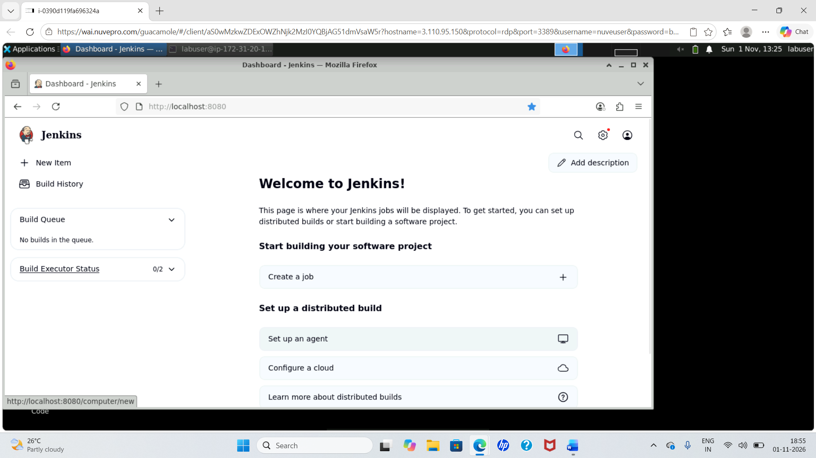

Original screenshot 02
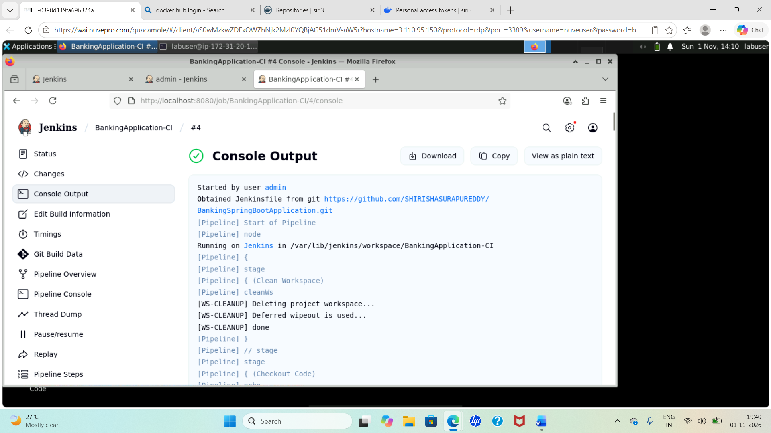

Original screenshot 03
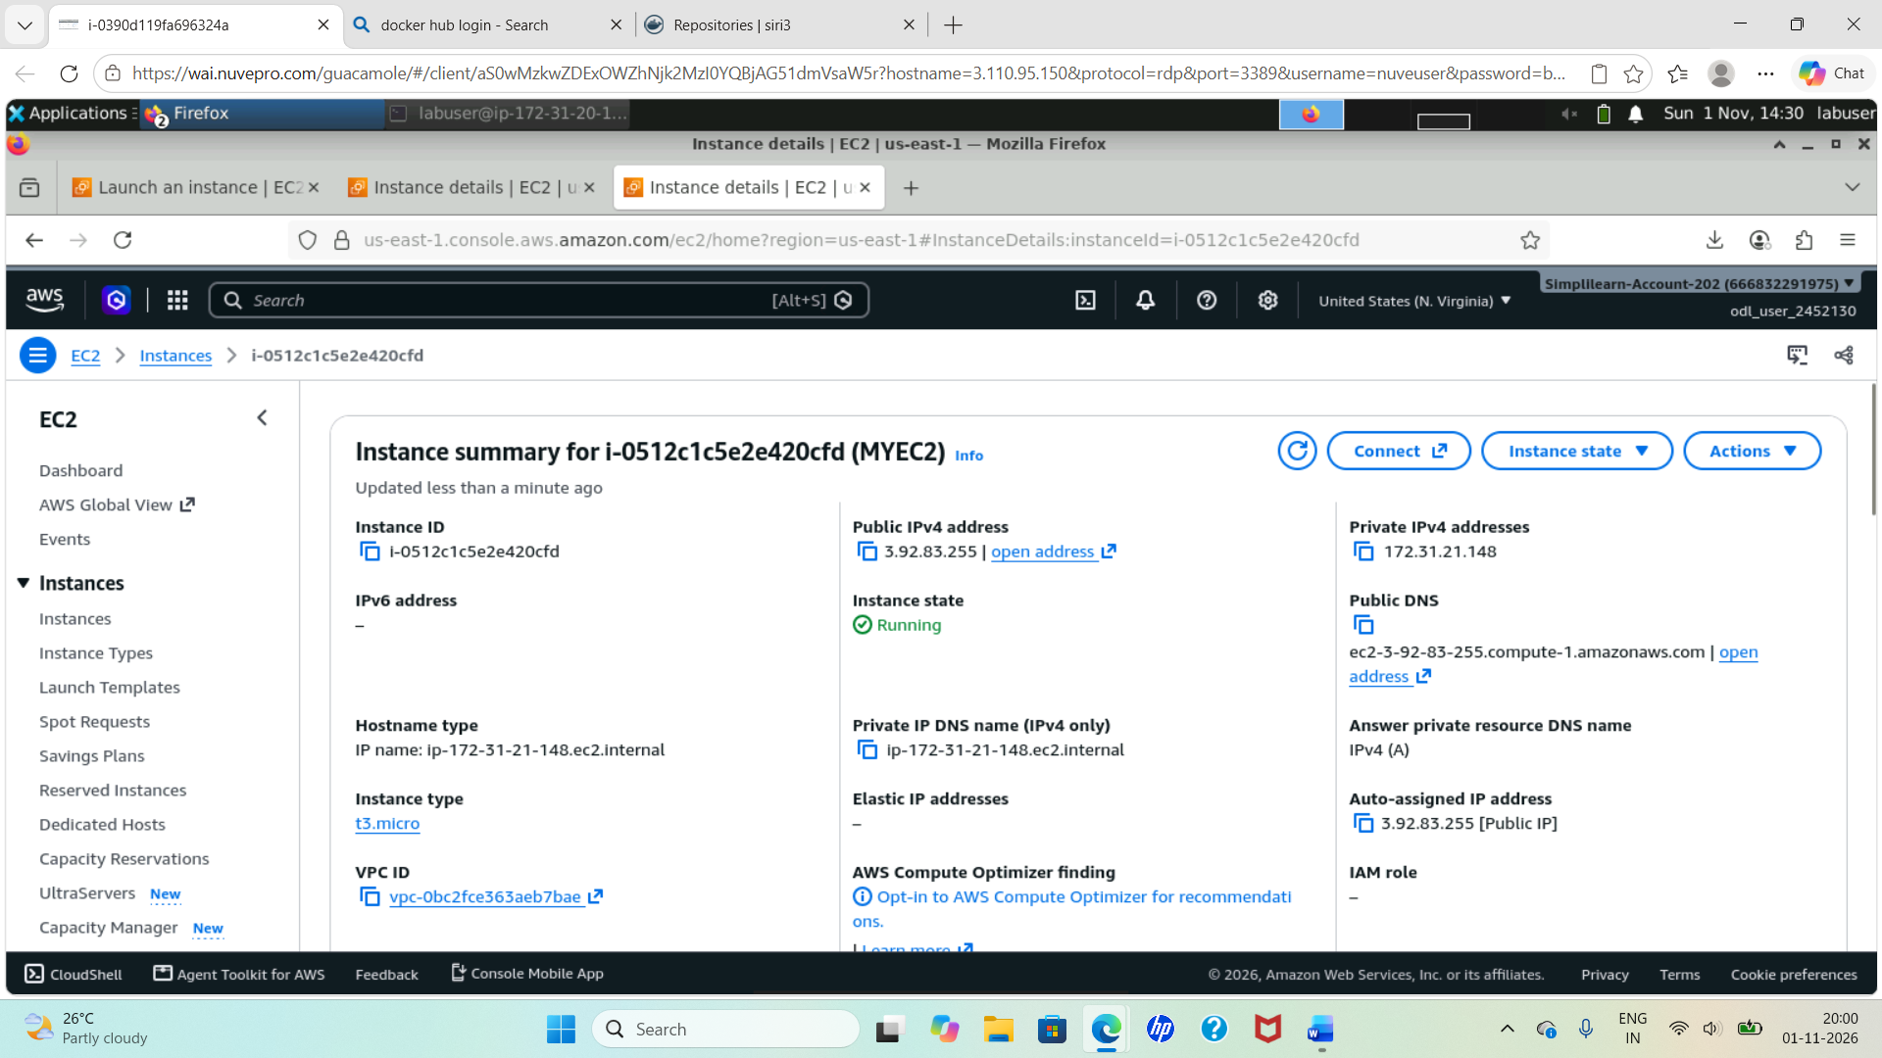

Original screenshot 04
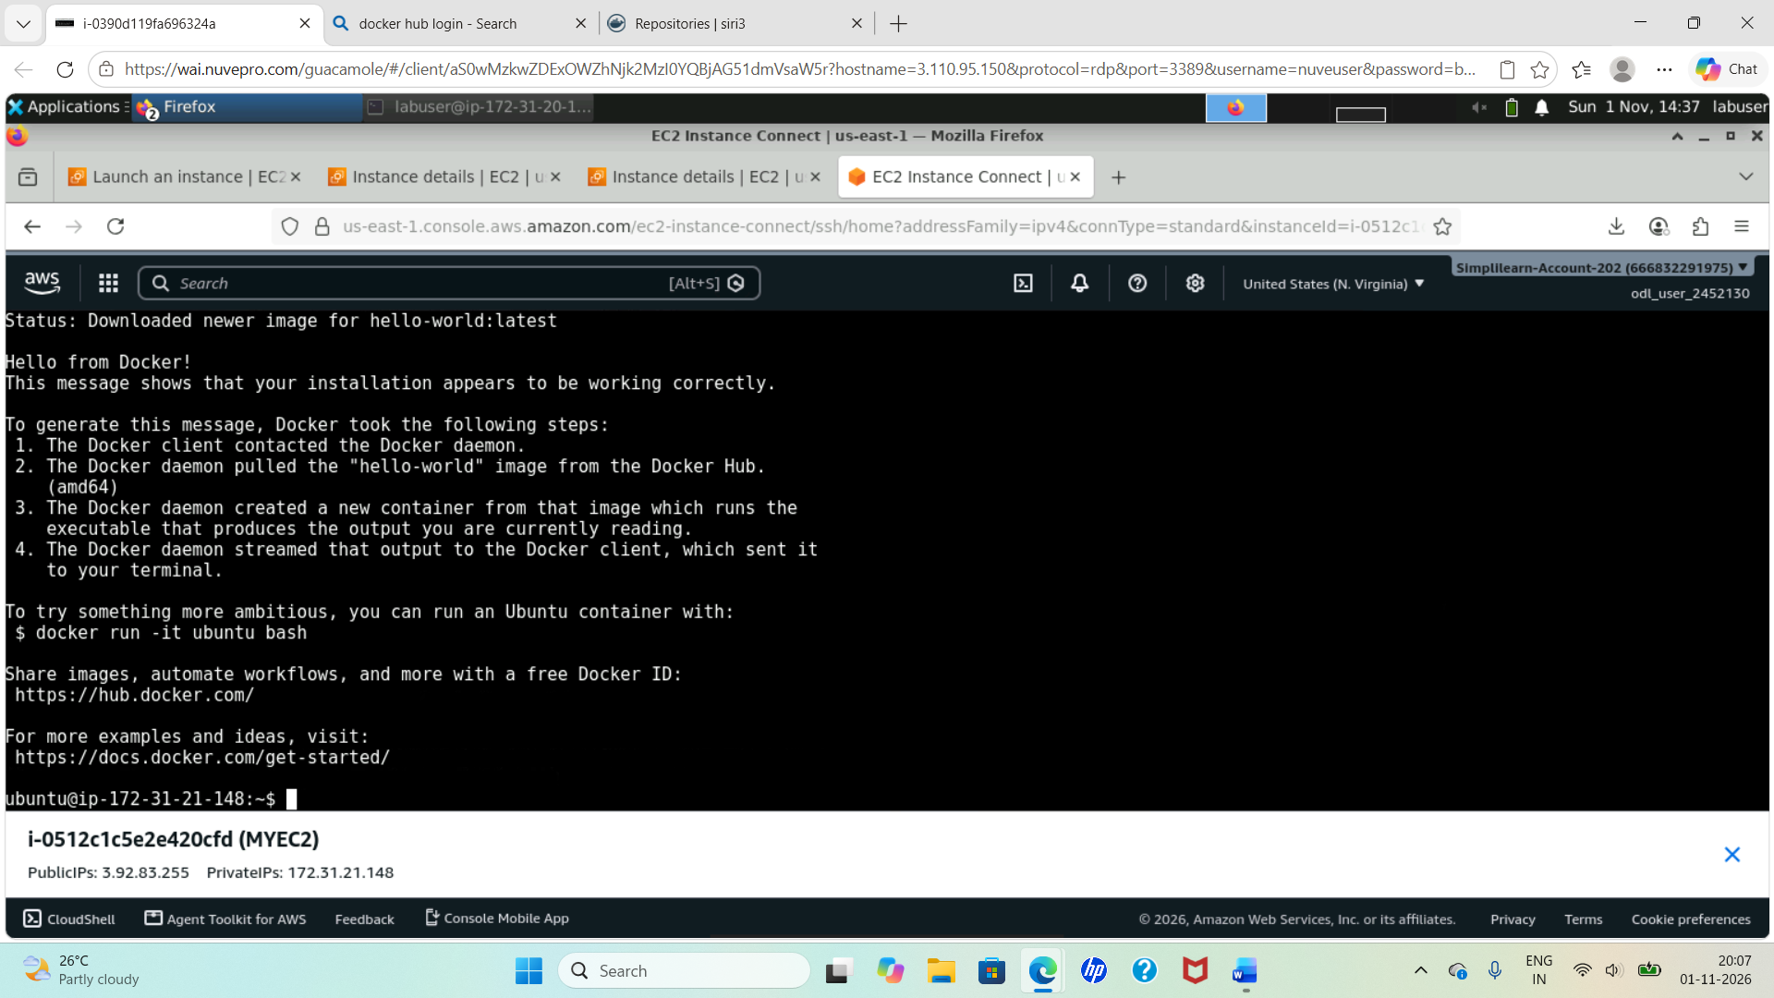

Original screenshot 05
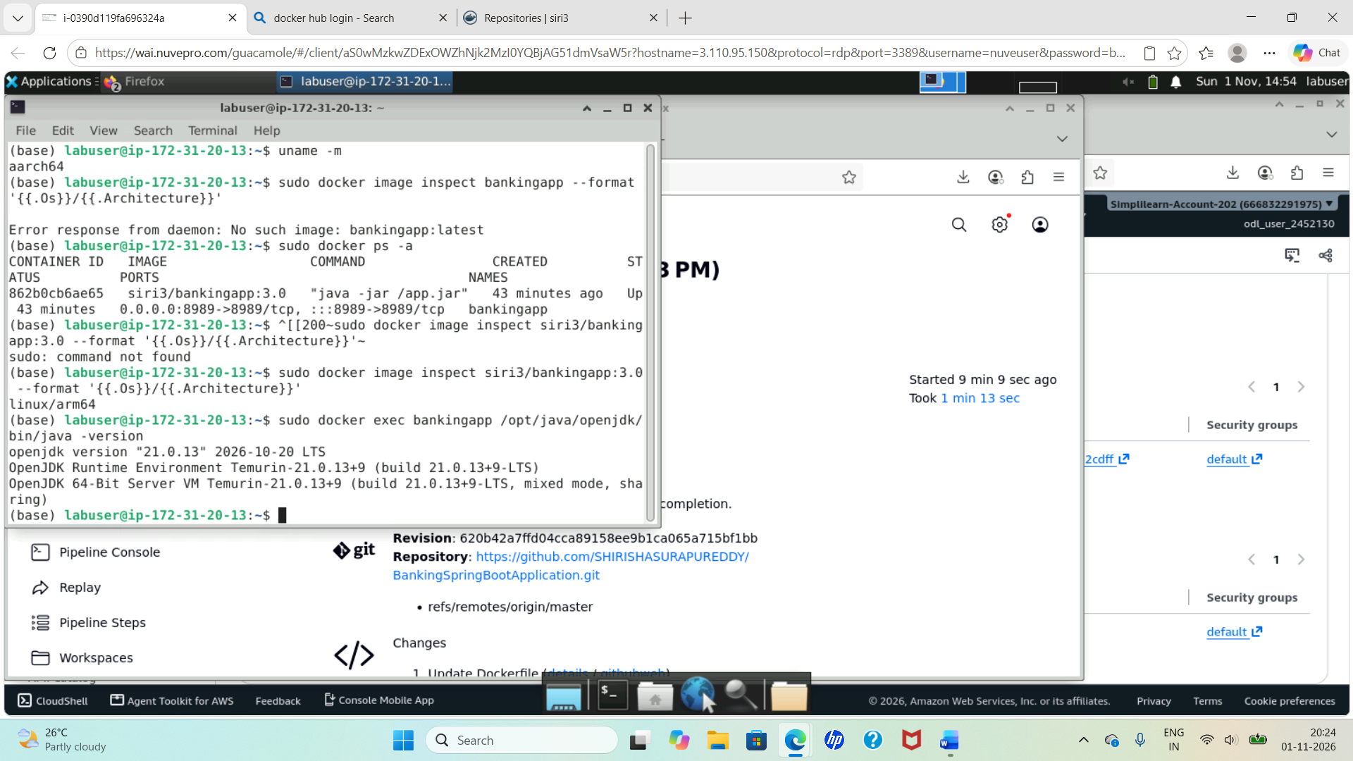

Original screenshot 06
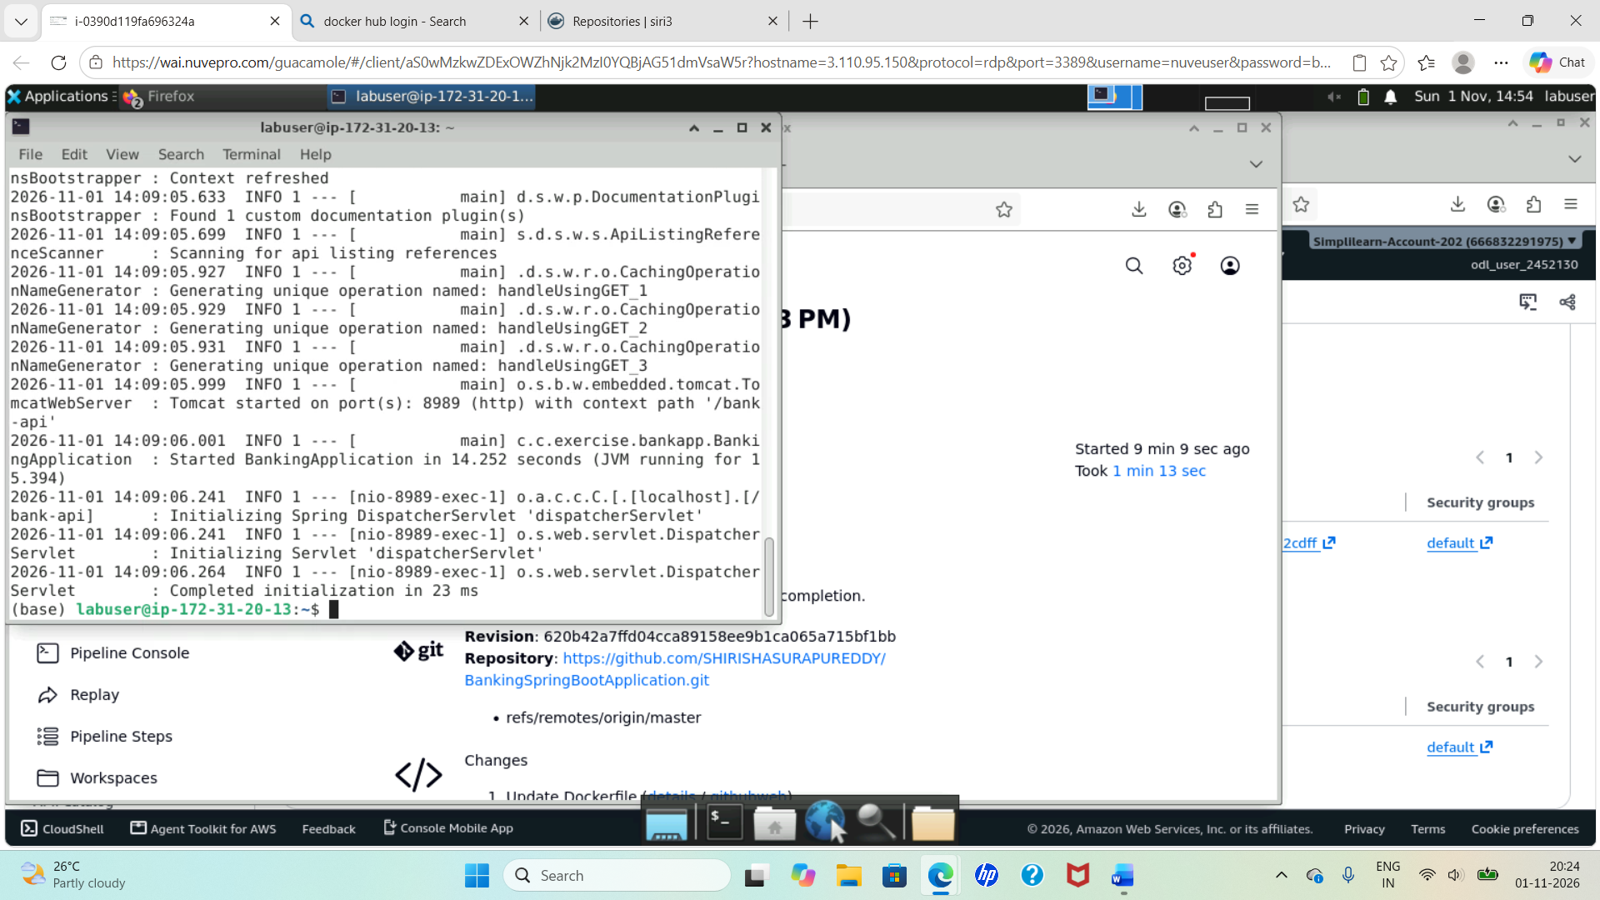

Original screenshot 07
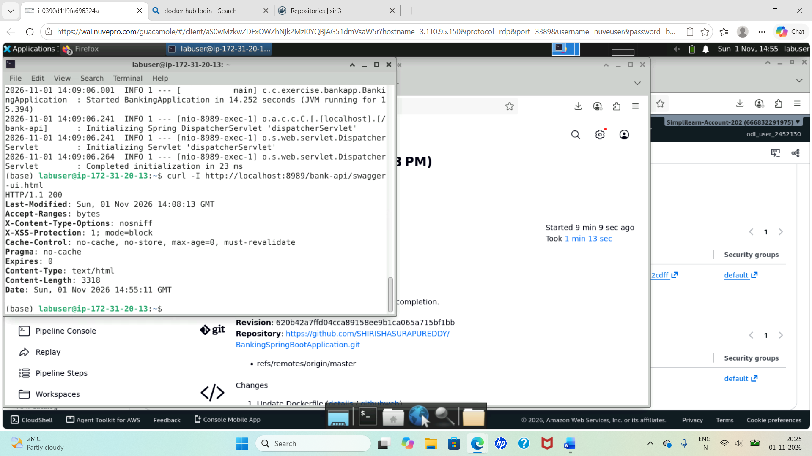

Original screenshot 08
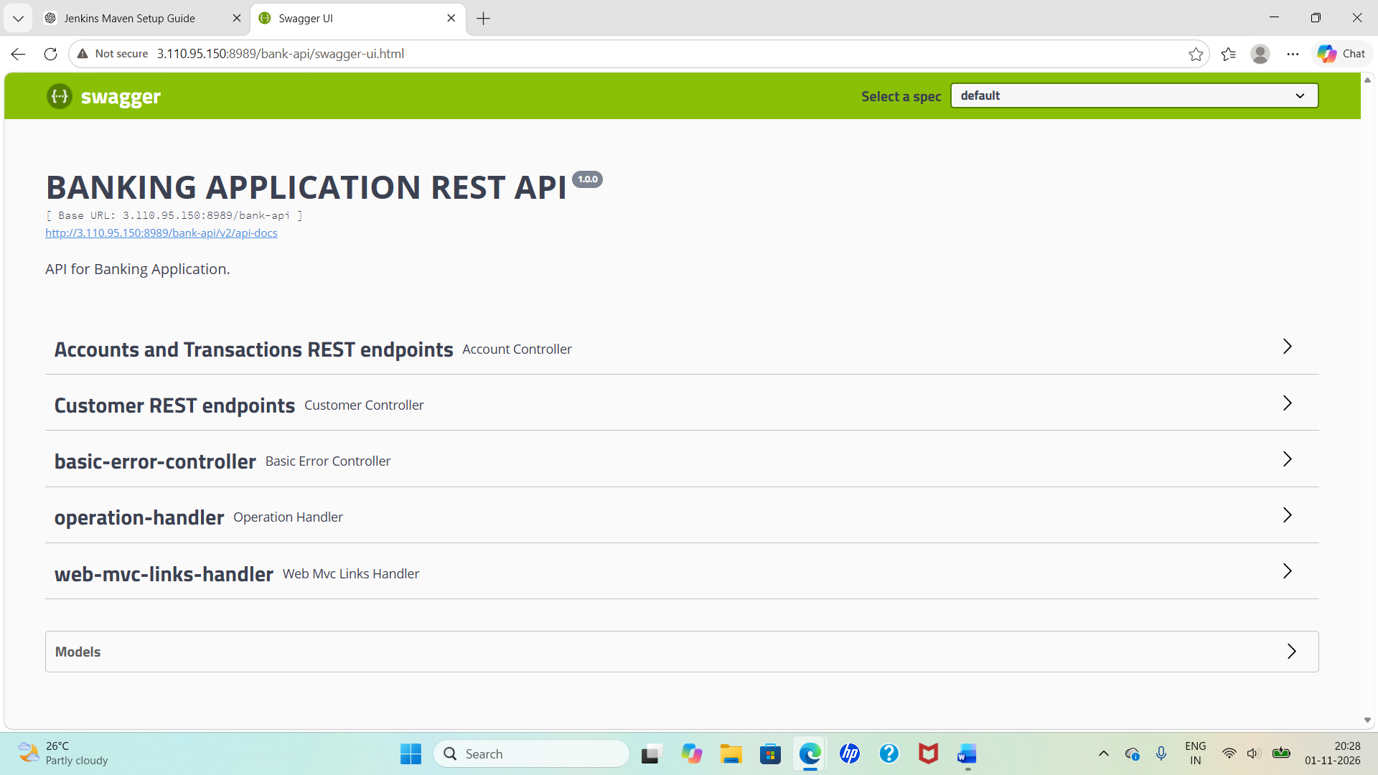

Original screenshot 09
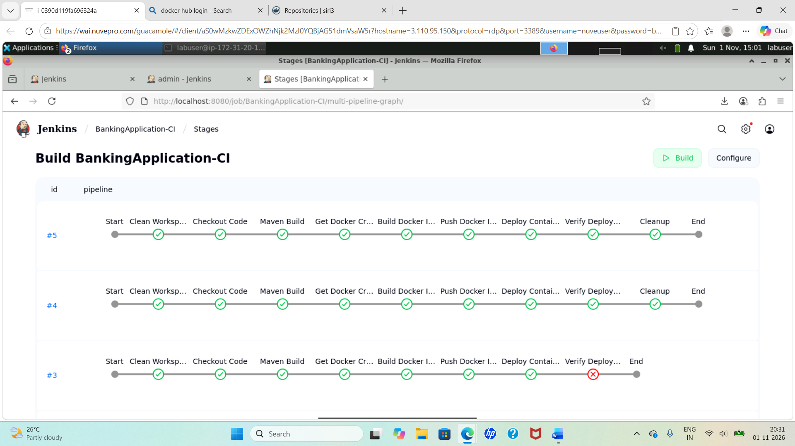

Original screenshot 10
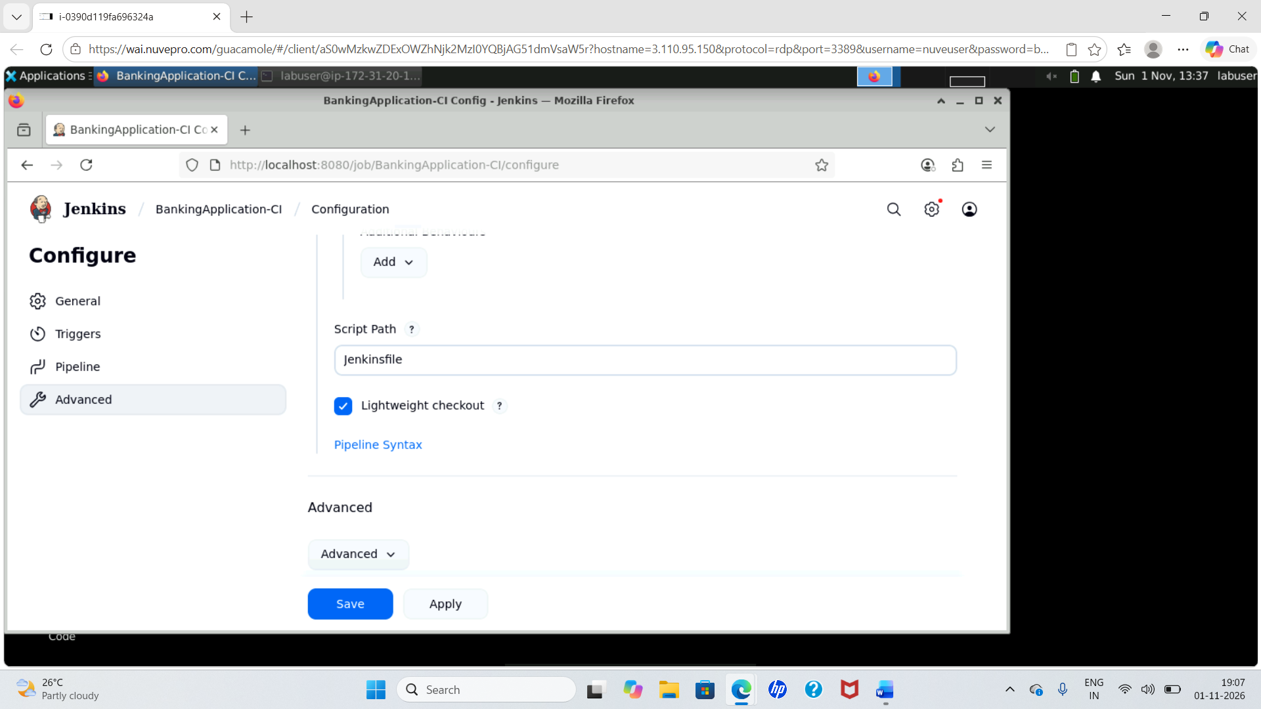

Original screenshot 11
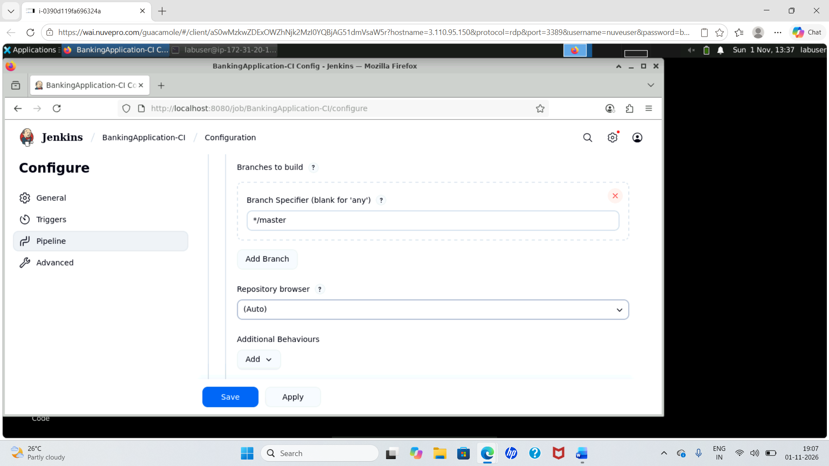

Original screenshot 12
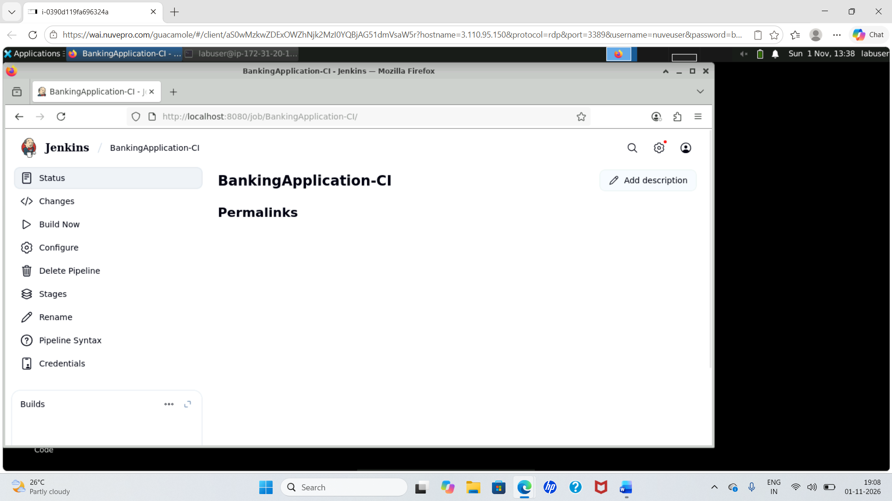

Original screenshot 13
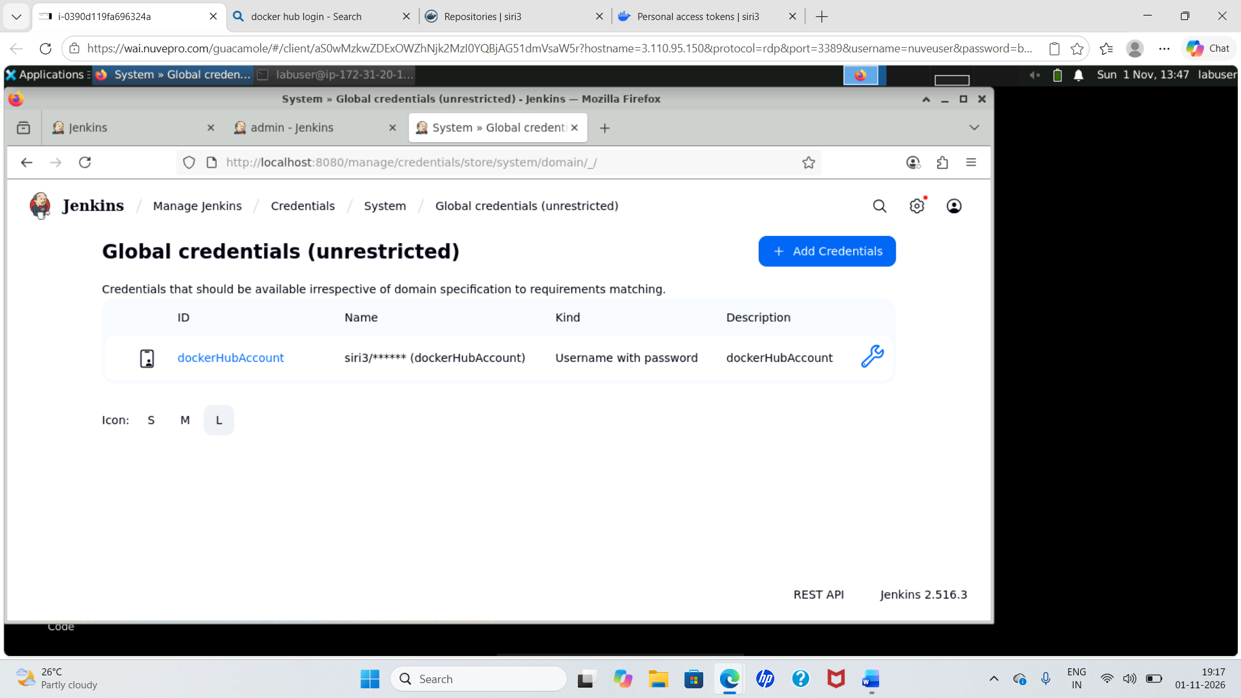

Original screenshot 14
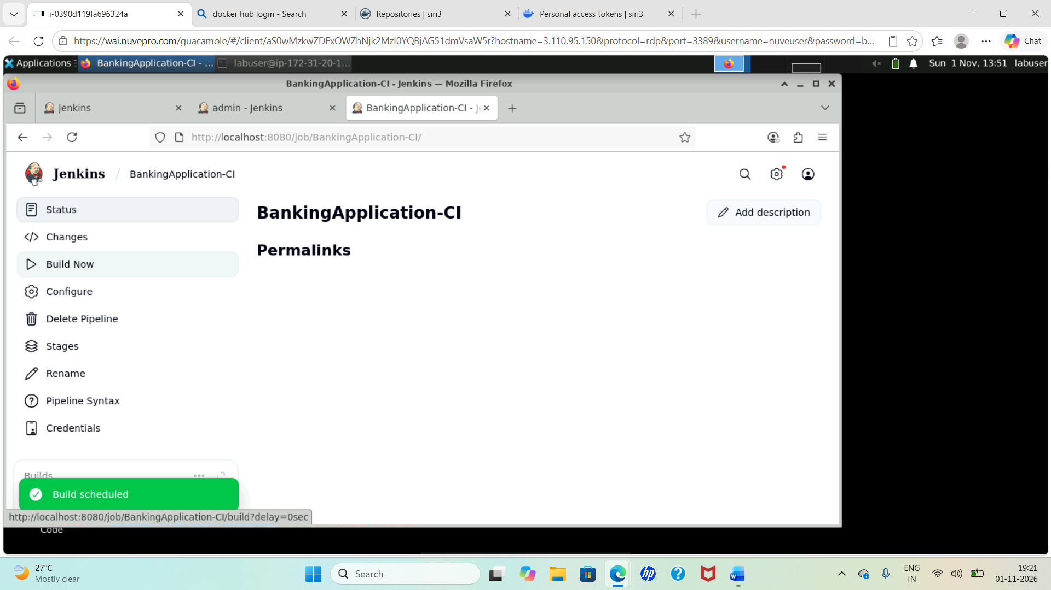

Original screenshot 15
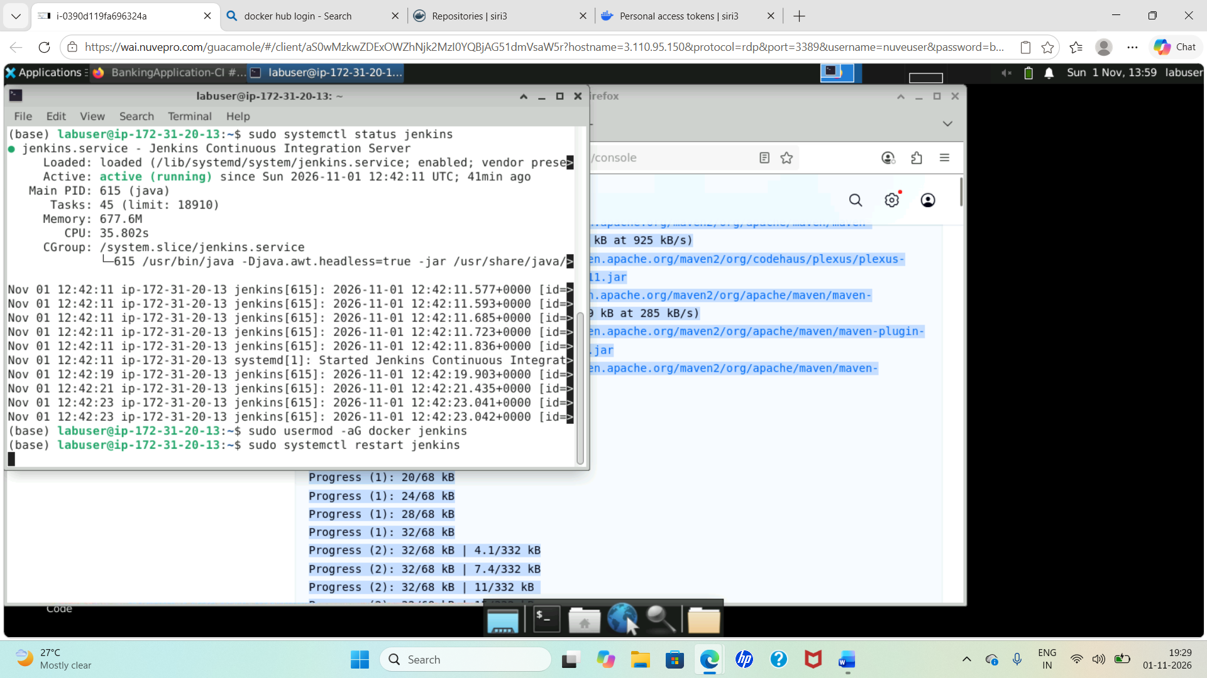

Original screenshot 16
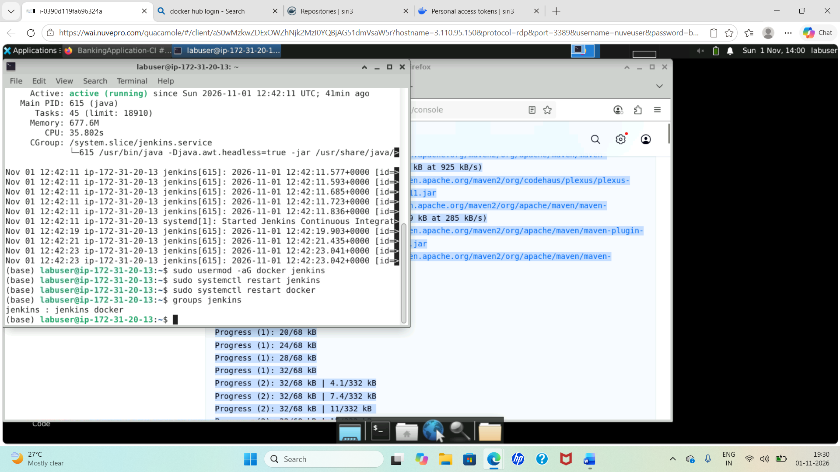

Original screenshot 17


